Savage Stone Age - Paleolithic Man- Movie Notes
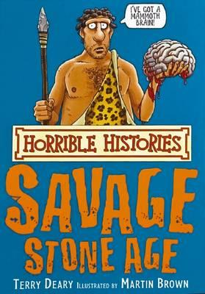

- Where Neanderthals around during the time of dinosaurs?

- Why are opposable thumbs so important?

- How did Neanderthals get their food?

- What did Neanderthals eat?

- How did Neanderthals cook their food?

- How did Neanderthals treat a headache?

- Who has larger brains: Neanderthals or modern man?

- How did Neanderthals communicate with each other?

- What kind of tools did Neanderthals use?

- What did Neanderthals live in?

- What is a “nomad”?

- How did the Neanderthals cook their food?

- What separated man from animals?

- What did Neanderthals use to make their cave paintings?

- Did Neanderthals grow crops?

- What happened to the Neanderthals?

Extra credit: What did Neanderthals use as toilette paper?

